Bond Report
This week’s bond trading saw pretty consistent sell off throughout the week. As bonds were sold off yields went higher, this continually happened, until the 2-year yield reached a post crisis high. The opening portion of the week was dominated by optimism returning to Japan with a business survey showing that the Japanese people were once again optimistic about the current place and future of their counties economy. The middle portion of the week was dominated by the debates over whether or not Yellen will maintain her chair or Powell will take it. This debate was fueled by the speech given by Janet Yellen that foreshadowed rate increases. Powell also made comments that seemed to be much more closely aligned with the president’s sentiment making many believe that Powell may bring some efficiency to the seat. The end of the week received a hard push from wage growth, which is thought to have stemmed from job creation. The belief is that this wage growth will lead to inflationary conditions which again led to a sell off. It is worth noting that throughout the week these conditions were pushed by the ever looming threat of tax cuts which returned to the agenda once again. The closing for Fridays treasury bills were: 2-Year T-Bill = 1.511%, 10-Year T-Bill = 2.370%, and 30 T-Bill = 2.970%.

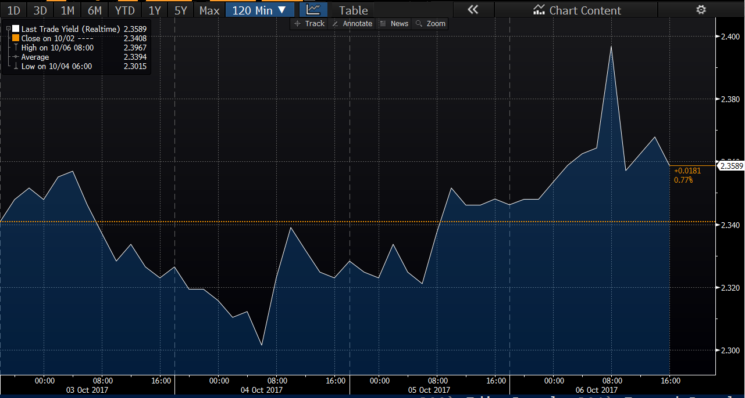

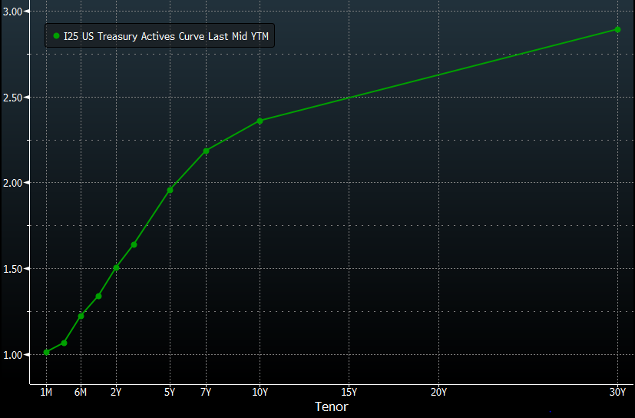

What’s next and key events

In the week to come we will experience a 4 day week since Columbus day (Monday) is a national holiday. Following Monday we have the 3 month, 6 month, 4 week, and 52 week auction which hold obvious implications in bond yields and prices. The Auctions will continue Wednesday with the 3-Yr Note Auction and the 10-Yr note Auctions. On Thursday the economic information to look for will be Jobless claims. Jobless claims will directly reflect how employment is working, which has an impact on wages, and will determine whether the expectation of inflation is warranted. The final economic factor to look for is on Friday the Consumer Price Index is released, this will give direct commentary on inflation and have a major impact on bond yields. Throughout the week bond analyst can expect to constants to impact bond prices. The first constant will be the outlook on the probability of tax reform. The second being Janet Yellen’s comments effecting the probability of whether or not she maintains her seat.

