Bond Report
Rates rose during this trading week. The cause for the increase in rates came from two main causes, both political in nature. The first cause for the increase in rates came from speculation on who will take chairmen of the FED in February. Janet Yellen has been written off along with multiple other candidates for the seat. Trump has made comments this week about how very close he is to making a decision on who will replace Yellen. The consensus at the moment is that John Taylor from Stanford will be replacing Yellen. This, of course, has not been finalized and may change. The next political event that has been pushing rates up is the hope of tax reform finally being accomplished. With the tax reform looming business are beginning to get active in their wishes to get it past. Wall street journal reporting that businesses are even encouraging employees to become active in encouraging politicians through lobbying. Bonds ended this week at: 2-Year Treasury yield – 1.6%, 10-Year Treasury note – 2.426%, 30-Year Treasury bond Yield – 2.92%
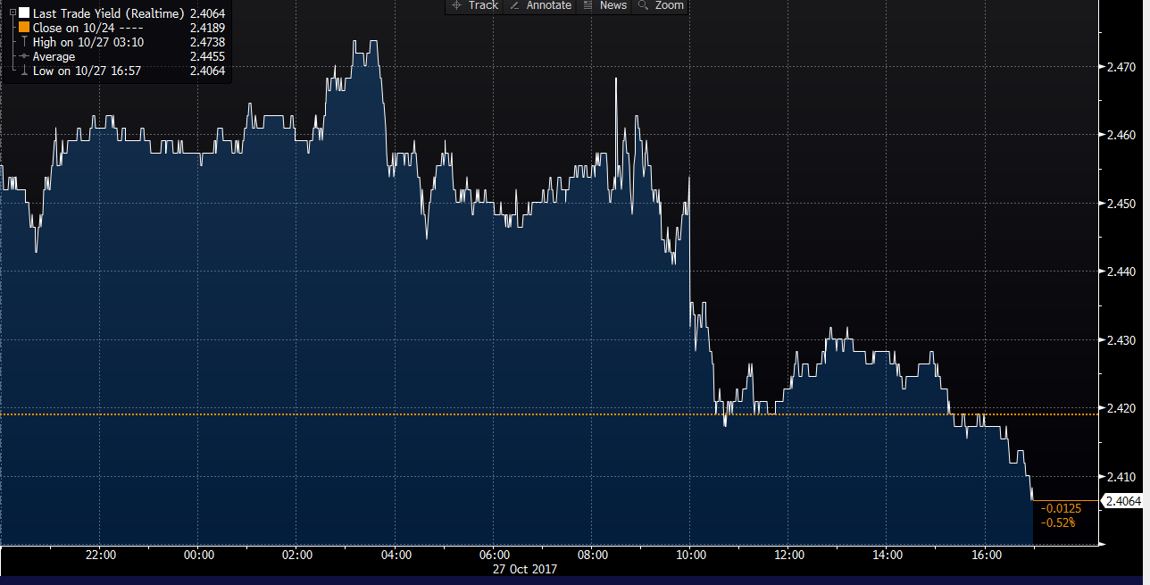

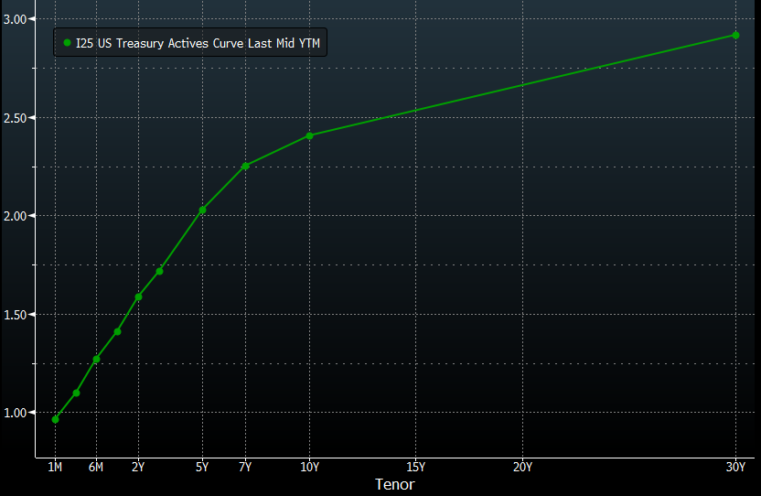

What’s next and key events

In the week to come we should receive more information on the two political conditions that affected rates so much this week. Although there is no set time frame, Trump will most likely give a more definitive name on who will be replacing Yellen at the FED. Also, congress may feel added pressure from lobbyist to make a more defined time line on tax reform in this coming week. Two major pieces of economic data will be coming out at the end of this week. On Thursday jobless claims will be released which will give some indication on employment. On Friday more indicators on employment will be released when the employment situation is released. This information may give indication to how wages will be doing in the future and through this inflation can be extrapolated. With inflation the FED may be more likely to engage in large federal funds rate hikes which could lead to large impacts in rates.

