Bond Report

The bond market yield volatility continues as it has the passed couple of weeks. The imposed Trump tariffs on steel and aluminum are one of the main drivers of this volatility. Overall, the tariffs are causing an increase in yields. In addition to the tariff uncertainty, treasury yields are up due to strong job growth which is keeping the Fed on track. Yields are still expected to rise in the coming weeks as planned by the Fed. The Fed believes that meeting an inflation rate of 2% will not be an issue. Yields ended with 2 year note at 2.262%, 10 year note at 2.896%, and 30 year bond at 3.161%.

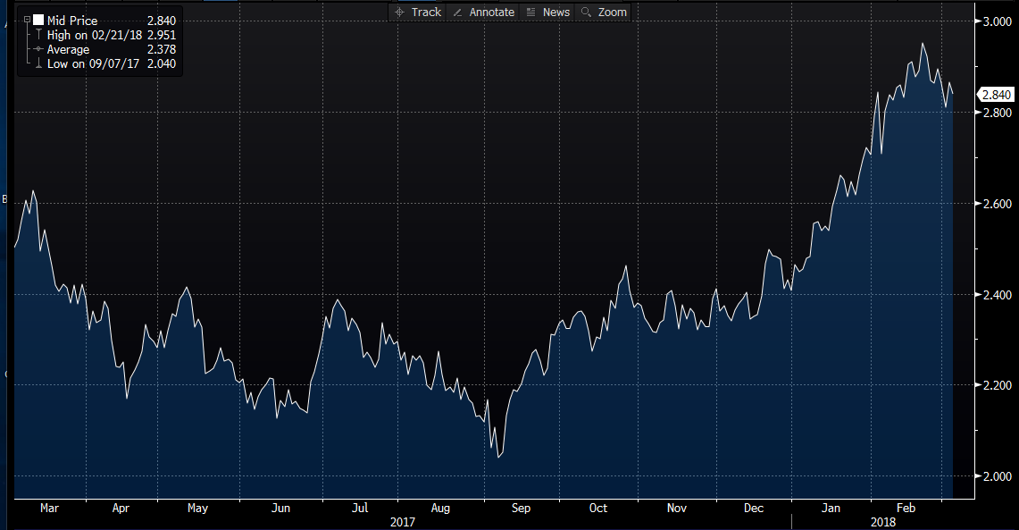

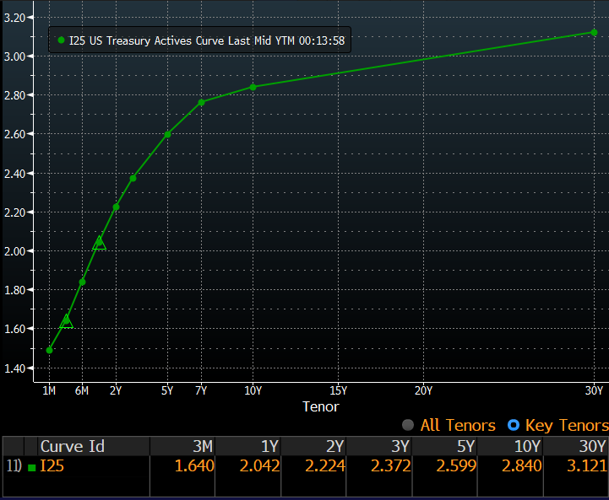

What’s next and key events?

Keeping a close eye on the effects of the import tariff on steel and aluminum Trump imposed is going to be important for the near future. It will also be important to track other macro factors such as unemployment. Investors continue to track the European Central Bank rates and their asset purchases as rates have remained constant in Europe.

