Bond Report

The bond market yields continue to fluctuate. They decreased this week due to bond investors rushing to complete their month-end trades. Yields increased on Friday because of Trump’s announcement about placing tariffs on steel and aluminum. Yields are still expected to rise overall in the coming weeks in order to combat creeping inflation. Professionals such as Paul Tudor Jones, expects 10 year yields to climb as high as 3.75%, which is over a 30 percent increase in total. Powell continues to convey optimistic messages about the economy and growth prospects, he is confident that inflation will meet the 2% objective, he also signaled that there will be as many as four gradual rate hikes this year. Yields ended with 2 year note at 2.222%, 10 year note at 2.839%, and 30 year bond at 3.120%.

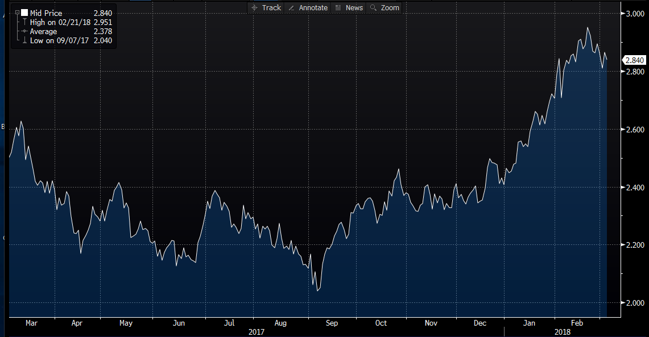

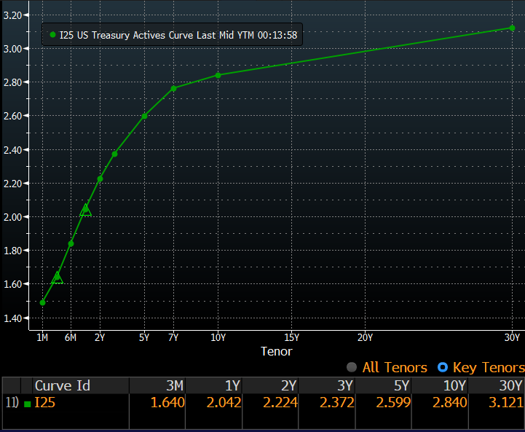

What’s next and key events?

One Item to look for in the future is the continuing impact of the tariffs that Trump levied on foreign steel (25%) and aluminum (10%). These tariffs could ignite a global trade war which would cause a hike in prices for goods and services. The possibility of a fourth rate increase by The Fed is another event to keep an eye out for.

