Bond Report
Last week in the market, North Korea tensions kept money pouring into the bond market early in the week, while a shift later in the week from political news pulled money back out. On Monday, yields were down from continued threats from North Korea and the weekends German elections. Investors are trying to find safe investment vehicles in the time of political and global uncertainty. Tuesday, yields rose around a basis point collectively after Janet Yellen gave a more elaborate response to the upcoming rate hikes. She reiterated that even though the target inflation of 2% hasn’t been met, it is entirely necessary to push rates up from post-recession lows to avoid inflation rising too rapidly. Experts are projecting a 78% chance of the third rate hike this year in December. Wednesday’s trading drove the 10-year yield 8 basis points up and the 30-year up 9.8 basis points, the biggest 1 day jump in the past 6 months. Trump released details on the proposed tax plans to cut corporate tax rate to 20% as well as individual household tax reform. The news was well received and a sell-off caused the jump in rates. On Thursday, prices remained fairly stable as the market sentiment tried to put a number to the likelihood of success in tax reform. The process is likely to be complicated and have some roadblocks, but overall confidence looks to be high. Closing the week out, news of Trump interviewing for Janet Yellen’s replacement hit the market. The 2-year and 10-year both rose 2.4 and 2 basis points respectively. The 2-year closed at 1.479% and the 10-year closed at 2.328%. The 30-year fell 1 basis point to close the week at 2.859%.

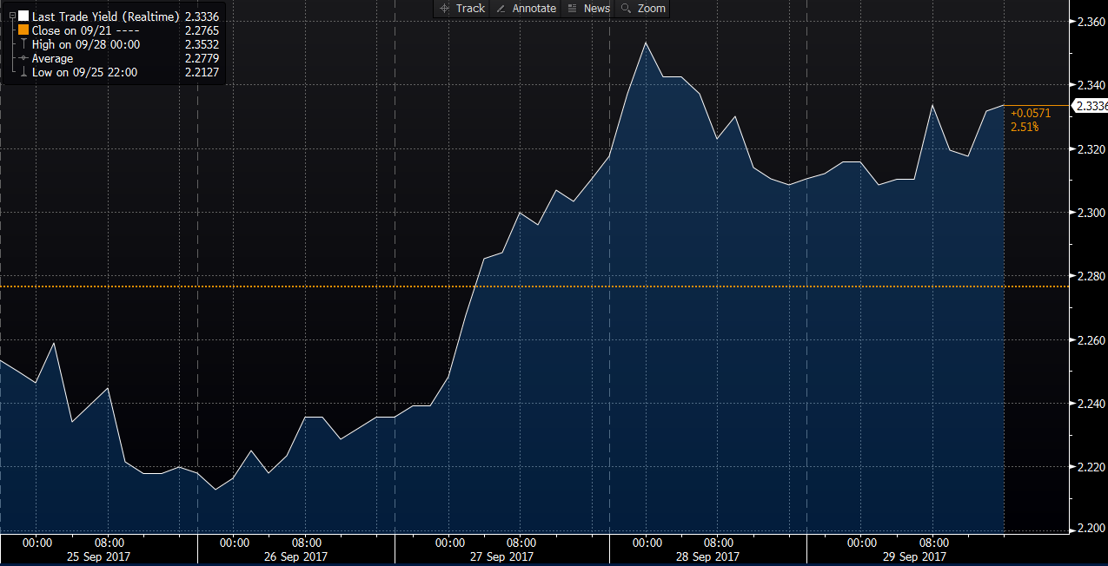

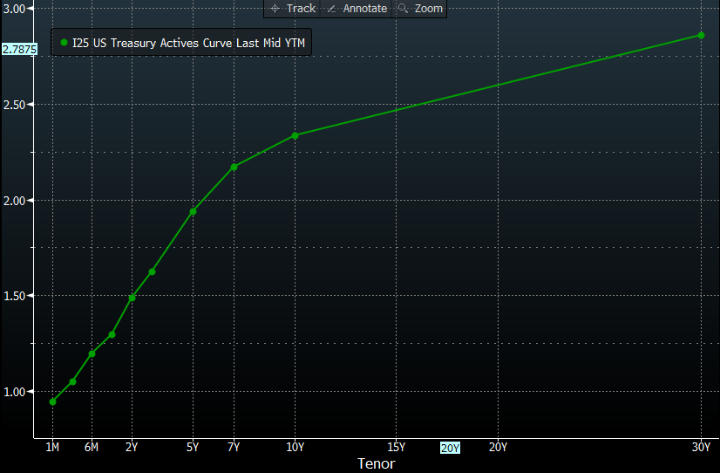
What’s next and key events

This coming week we should expect to see some volatility as sentiment on President Trump’s effectiveness in Office. Tensions in North Korea are also of concern, which will likely cause more volatility and a potential rush from investors again. Some other key events to watch include Monday’s Construction Spending report. We hope to see some insight on the relief efforts after the past two Hurricanes to gauge where the market will move. On Wednesday, Janet Yellen is set to deliver open remarks to the Community Banking in the 21st Century Conference, so we expect to hear more from her on what to expect on rate hikes in more certainty. Lastly, we are in a very macro driven environment, so pay close attention to any events concerning Trump, North Korea and GDP growth. Overall, it is safe to say the volatility experienced will continue into this week and outside geopolitical tensions and spontaneous news about President Trump will continue to bring that to the bond market.

