Paul Martinez
Bjorklund Fund
April 11th, 2018
Generac Holdings, Inc. (GNRC)

SUMMARY: Buy Generac Holdings, Inc. (GNRC) at its current price of $45.79. I believe that there is a possible bullish return of close to 32% and a realistic return of approximately 17% with target prices of ~ 61 and ~54 respectively.

BRIEF DESCRIPTION: Generac is a leading global designer and manufacturer of a wide range or power generation equipment and other engine-powered products serving the residential, light commercial and industrial markets. In addition, Generac is a leading provider of light towers, mobile generators, flameless heaters, outdoor power equipment, and industrial diesel generators. The company operates primarily in the following segments:
- Residential Power Products – 52% of Total Revenues
- Commercial/Industrial Power Products – 41% of Total Revenues
- Other Services – 7% of Total Revenues
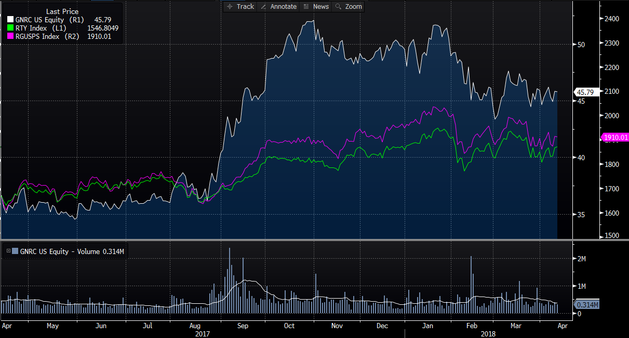

- “Powering Ahead”
  - Management’s strategic plan to create value and drive stock price.
    - Drive continued increase in the penetration rate of home standby generators
    - Expansion of Commercial and Industrial segments to continue gaining market share
    - Capitalize on Generac’s competitive advantages
    - Growing and improving profitability global business
- Strategic Acquisitions
  - Generac has completed ten acquisitions since 2011. Through these acquisitions, Generac has been able to expand their geographic capabilities and diversify their product lines.
    - Recent acquisitions – Selmec and MotorTech
    - Margin expansion – Selmec margins are higher than current margins
    - International exposure – Mexico City, Mexico and Celle, Germany
      - Over 6,000 dealers
    - Product line diversity – New products, customers, end markets
- Industry Position
  - Generac is an industry leader
    - Strong organic growth
      - Q4 2017 showed organic growth of 17% from prior year quarter
      - Strong core international growth in all segments
    - Long-term growth themes
      - Tax reform will positively impact GNRC
      - Increased products allows for new market penetration which results in market opportunities
I believe that Generac Holdings has put in place a core strategic plan and has seen constant organic and inorganic growth of mid to high single digits. Generac has recently put forth very conservative guidance because they do not include/forecast for any major weather related event. Realistically, Generac is going to beat their guidance and outperform throughout FY 2018.

INVESTMENT THESIS:
- “Powering Ahead”
Powering Ahead is management’s strategic plan, which frameworks their core goals and investment opportunities. This plan is broken down into four major drivers. First being Generac’s focus on continuing to grow their residential standby generator. This is what Generac is most known for and currently are a leader in. With this being said, their primary goals in this area are to increase awareness and cut costs. By increasing awareness, management has estimated that for 1% increase in penetration there is approximately $2 Billion in sales opportunity. Next management focuses on their other segment, Commercial and Industrial products. Generac looks to gain more and more market share in this segment. Generac has been doing this by expanding their distribution channels both domestically and internationally. For every 1% increase in market share there is approximately $35 Million in sales opportunities. Generac’s third major driver in this plan is to capitalize on their competitive advantages. By using cleaner burning and more cost effective natural gas, Generac has been able to attract more business and increase market share. Finally, what I believe is the most important aspect of Generac’s business, expanding their global presence. In 2017, Generac was able to increase their international revenues 22% compared to 2016. Management has been focusing on this market through strategic acquisitions of companies, such as Selmec and MotorTech. International business aims to improve margins, and cut costs based on synergies. Management believes that outside of the US & Canada there is a $13.5 Billion dollar market still to serve in this industry. I believe that this core strategic focus will allow management to focus on what creates value and drives growth.
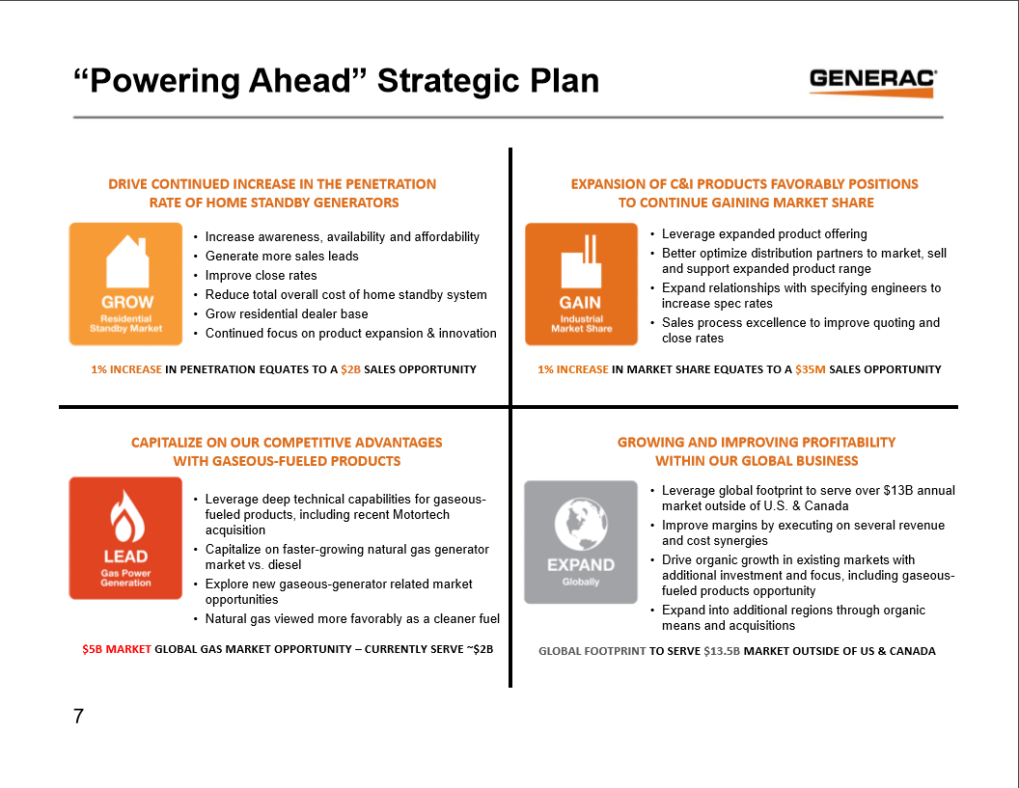

- Strategic Acquisitions
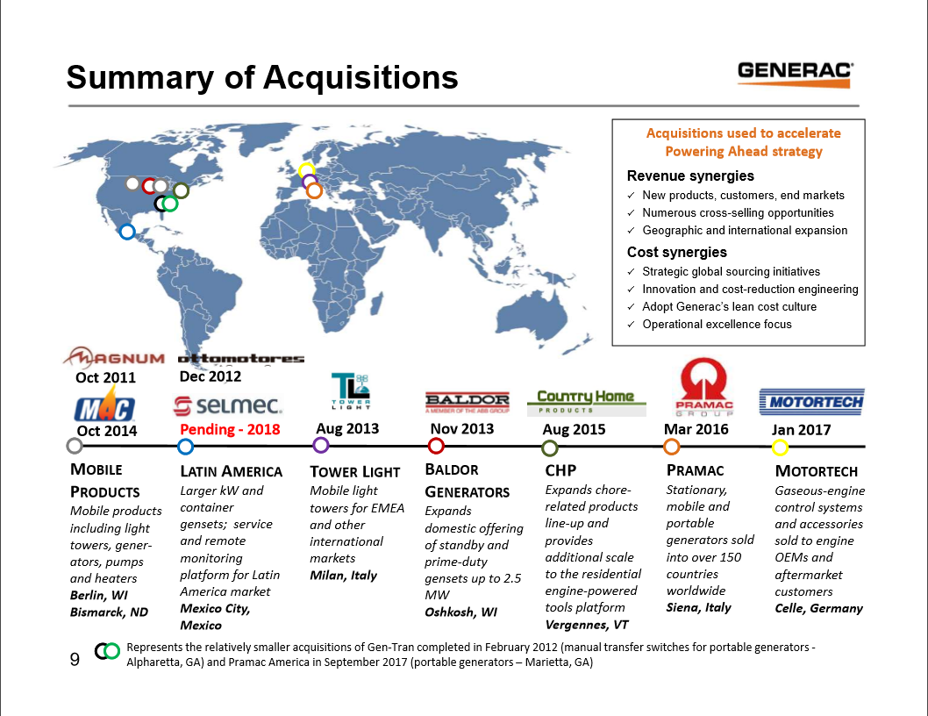
Over the past seven years, Generac has acquired ten companies all around the world. Below is a snapshot of Generac’s M&A history.
There are three recent acquisitions that I want to focus on, which I believe are going to create the most synergies and provide the most benefit to Generac in the future.
- Pramac Industrial – Siena, Italy (2016)
  - Generac acquired majority share in 2016 and then acquired the rest of Pramac shortly after.
  - Pramac is a manufacturer of stationary and mobile generators for commercial and industrial applications.
  - Pramac sells into more than 150 countries and has a broad distribution network.
- MotorTech – Celle, Germany (2017)
  - Generac acquired MotorTech at the beginning of 2017
  - The acquisition of MotorTech added gaseous-engine control systems and accessories to Generac’s product line. These products are primarily sold to European gas-engine manufacturers and to aftermarket customers.
  - “By combining resources and technology, Generac and MotorTech will lead the industry in innovative, spark-ignited engine generator offerings” – EVP at Generac
  - Q4 2017 - $9.6 Million in net sales
- Selmec – Mexico City, Mexico (2018)
  - On February 13, 2018, Generac signed a purchase agreement to acquire Selmec Equipos Industriales, headquartered in Mexico City.
  - Selmec offers a market-leading service platform and specialized engineering capabilities, together with robust integration, project management and remote monitoring services.
    - Selmec produces industrial generators in the ranges from 10 kW to 2,750 kW, which fills a niche market that Generac previously did not have.
  - Higher margins
As you can see, Generac has made strategic acquisitions. These acquisitions have allowed Generac to increase their distribution channels and grow internationally, diversify their product line and service more customers, and finally, increase revenues and expand margins. Due to these major three major acquisitions, I believe that Generac will be able to increase revenues, cut costs, and expand margins.

- Industry Position
With all of their strategic acquisitions, Generac has been able to position themselves as an industry leader in many ways. Generac has been able to expand their global footprint and increase market share throughout each acquisition. In addition to this inorganic growth, Generac has seen strong organic growth both domestically and internationally. During Q4 2017, GNRC experienced growth all across the board. Residential Products were up 11.2%, Commercial and Industrial Products were up 27.1% and International sales grew 41.8%. Currently, Generac does majority of their business in the United States, however, management hopes to expand more globally. Furthermore, Generac has many macro trends that are leaning in their favor as well. One example is President Trump’s tax reform. Generac currently has an effective tax rate of approximately 35%, but is expecting large benefits in their bottom line moving forward. Furthermore, below are some other macro factors that will lead to business for Generac during 2018 and beyond.
- Residential Segment
  - Aging and underinvested grid
  - Favorable demographics
  - Heightened power outages
- Commercial & Industrial Segment
  - Increase in global footprint with Pramac acquisition
  - Telecommunications are quickly growing, which is generating a crucial need for backup power for major telecommunications infrastructure

OWNERSHIP SUMMARY:
Investment Advisor’s own close to 90% of GNRC and have been increased their position over the past year. One aspect to note while looking at Generac’s ownership summary is seeing that Hedge Fund Managers have been decreasing their position. Hedge Funds normally have a short-term focus, exited their position, and assumed their profits. Over this, same period, GNRC stock price is up more than 31%.

