Macroeconomic Overview
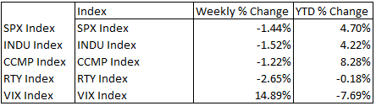
Domestic
U.S. equity markets ended this week in a slight suppression following an unanticipated outcome of President Trump’s healthcare bill. Confidence within indices across the board seemed to have dropped due to the outcome of Trump’s guidance, many of which had priced in the possibility of healthcare reform. With that decision delayed, losses were accentuated by dipped shares in the financial sector and increased volatility proven by the spike in the VIX. However, this week’s biggest loss can be seen within the Russell, indicating a major sensitivity to congressional actions. Mid-caps alone are seen as the largest gainers of Trumpenomics, capitalizing on everything from reduced regulation to tax reform. Due to the placement of most mid-cap companies, there is a lot more room for growth as they mature into larger firms. However, with that potential, there comes a higher sensitivity to macro events, such as the healthcare delay. Paired with the movement of many mid-caps, financials are also seen to capitalize mostly on reduced regulations. The financial sector losses not only stem from the aftermath of the healthcare delay but also the market’s outlook on Trump’s future endeavors. Currently, the market shows that he, and his administration, will be facing more headwind than expected.
Moving into next week, and the prolonged future, healthcare deserves another look. With the markets responding to the pessimistic outlook of its future, components of the healthcare industry may be underpriced. Certain aspects, such as pharmaceuticals, may still face decline despite the movement in healthcare. The future dynamics of pharmaceuticals will be at the mercy of congressional support for lowered prices within the industry. In doing so, this can not only be reflected in the earnings of the company, but more importantly their reputation, and therefore a change in investor morale concerning the companies’ operations.
In the grand scheme of the market, we are approaching a time filled with uncertainty, and as any elementary school economist knows, uncertainty is the market’s enemy. The first 100 days of the Trump presidency brought economic guidance like none before, but we have seen the market’s reaction to a congressional roadblock. The next monumental piece of guidance will come from Trump’s widely-anticipated tax reform. If all goes well, we can expect an upturn in equities.

Foreign Markets
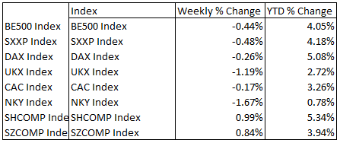
Europe: Across the pond, equity prices were mostly moved by a spike in U.K. inflation rates. February figures indicate that the rate jumped from 1.8% (Jan.) to 2.3%. This movement was faster and more robust than previously anticipated, accounting for the lack of positive movement within the U.K. equity market. To offset that, retail sales turned positive since the .5% decline in January, indicating a possible increase in consumer confidence. However, a single step forward is usually followed by two steps backwards. Volatility within European equities could be attributed to a terrorist attack in London, yielding loads of bearish behavior and overall uncertainty. With a violent attack aimed at the Palace of Westminster, consumer confidence drops and the movement of markets becomes abnormal. We expect somewhat of a normalization next week as guidance from Prime Minister May will encourage forward momentum and President Trump’s economic agenda moves towards its next growth policy.

Asia:
Japan experienced a loss this week following US trading markets and a stronger Yen. Recent economic data shows that exports rose on a YTD figure over 11% with a much smaller growth in imports, indicating a positive effect on the Yen thanks to the surplus. China maintained the most contrarian equity performance among all major indices this week. A positive week’s end can be attributed to gains in safer sectors such as infrastructure and energy. As the nation becomes more focused on a self-sustainable vision, the most basic factors of any nation are reaping positive gains. Could this be used as an insight in the light of looming uncertainty here at home? We would recommend you keep an eye on these areas, just in case.

