Company Description:
International Speedway Corporation, together with its subsidiaries, promotes motorsports themed entertainment activities in the United States. Its motorsports themed event operations consist principally of racing events at its motorsports entertainment facilities, which promote approximately 100 stock car, open wheel, sports car, truck, motorcycle, and other racing events. The company is also involved in food and beverage concession operations; the provision of catering services in suites and chalets; and the creation of motorsports-related programming content carried on radio stations, as well as Sirius XM Radio, a national satellite radio service.
April 11, 2018  International Speedway Corporation: (ISCA)  Jacob Perry | Sector: Consumer Discretionary  Industry: Entertainment Facilities  Current Price: $39.55  Target Price: $49.16

Buy
Current Price: $39.55 Market Cap: 1.803B
Target Price: $49.16 Volume: 150,000
52 Week Range: $47.45-$32.25 ROIC: 19.9%
Operating Margin: 14.3% WACC: 8.7%
Thesis: International Speedway Corporation shows an ability to consistently provide earnings that generate value for its shareholders. With the resurgence of auto racing, ISCA is poised to take advantage of the new popularity of the sport. | Catalysts:  - Short Term(within the year): Restructuring of current tracks, Tax act  - Mid Term(1-2 years): NASCAR popularity  - Long Term(3+): One Daytona fully operational
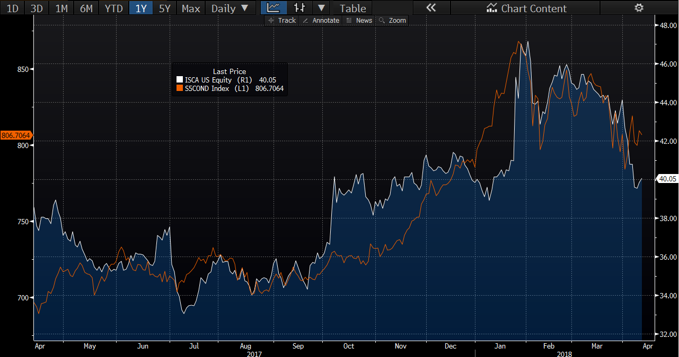
Net Margin: 10.9%

Earnings Performance:
International Speedway Corporation has seen a consistent trend of beating their earnings per share estimate in quarter one. The most recent earnings call, on April 3, was in line with their trend of past quarter one results. In regards to the 2018 Q1 results, executives in the company have identified that they beat this year’s Q1 earnings estimates on the basis of a tax cut. The effective tax rate for International Speedway is 27 percent. Non-GAAP earnings improved from $0.47 per share to $0.60 per share. Executives attributed the growth in earnings to the drop in effective tax rate for ISC. Without the initiation of a new tax rate, the earnings per share would have most likely missed estimates.
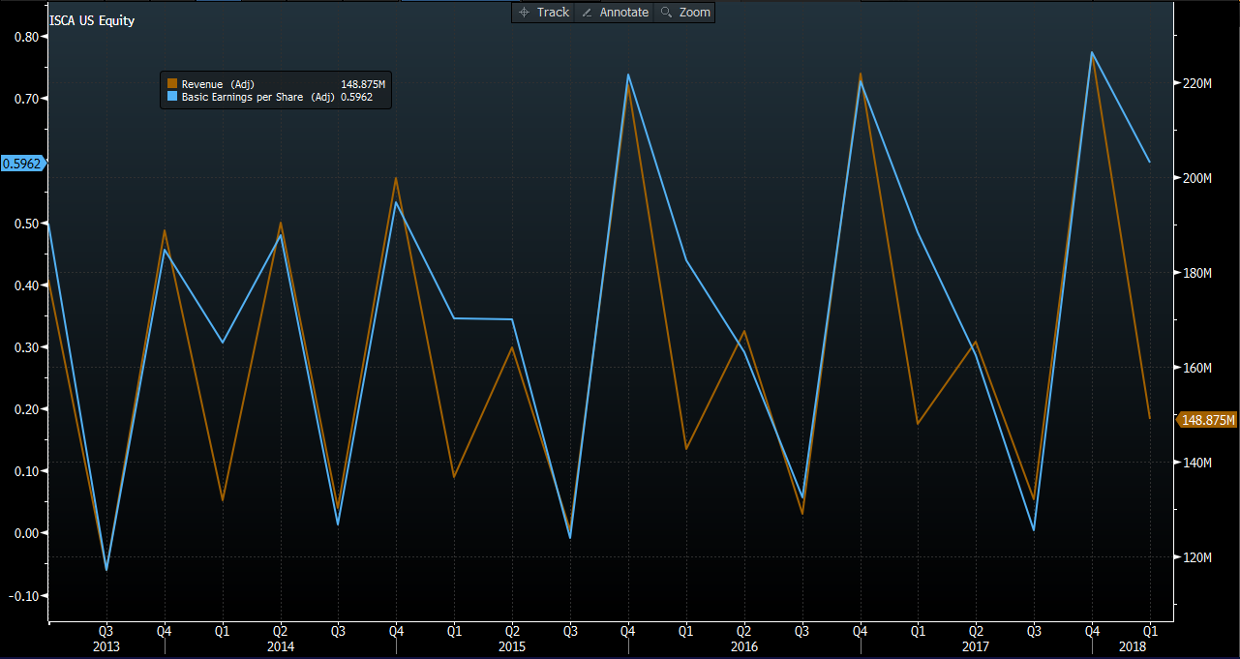
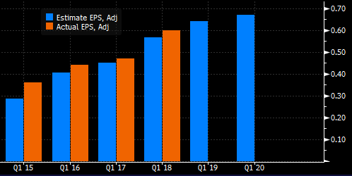
Revenue Growth varies depending on many attributes pertaining to auto racing. The majority of ISC’s revenue comes from NASCAR based events. The most notable NASCAR race is most certainly the Daytona 500. Since ISC owns multiple tracks, NASCAR holds 22 races on average at ISC racetracks in one race season. The tracks are different in their own unique ways, which gives ISC the ability to use them for many different auto events. This quarter, Daytona International Speedway hosted the Rolex 24 at Daytona, a race that spans over a continuous 24 hours. Strong corporate participation and sponsorship contributes to consistent revenue growth at the Rolex 24 and other ISC events. In addition to the increase in participation of corporate sponsors, the returns that specific racetracks are able to generate have also increased due to ticket price changes. The average price of a grandstand ticket at NASCAR Cup events increased to $170, a 1% increase from 2017. Since revenue drives earnings per share, ISC should see an increase in quarter two earnings as they have seen in the past. Systematically, quarter two is higher than quarter one. International Speedway has also seen occasions in which quarter two has been higher than quarter four regarding revenue. Either way, earnings will be higher in the next earnings call.

Competitors:
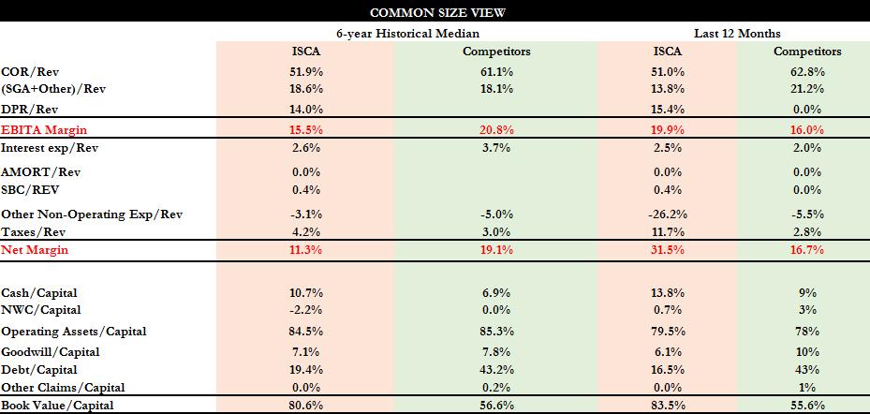ISC competes in a very segmented market with little to no other public companies. As an entertainment business, they can have some parallels drawn between themselves and other companies such as SeaWorld, Six Flags, and Cedar River. Granted, they do not provide the same services. Although, these companies all compete for the same market of entertainment and for some amusement parks, they compete with direct tracks. For instance, SeaWorld competes directly with Daytona International Speedway during the race season. In depth focus on the margins for ISC will show how proficient and different they are compared to these other companies. ISC’s assets are utilized in the production of their service, therefore they are depreciable assets. A depreciation to revenue ratio of over 15 percent shows its weight when comparing EBITA margins between ISC and other competitors. ISC’s competitors show a 16 percent EBITA margin while ISC boasts a 19.9 percent margin. When looking at the bottom line, the net margin of ISC is double their competitors at 31.5 percent. Over the historical median, ISC’s competitors show a stronger net margin than ISC. This is an indication that competitors lost ground versus ISC over the past six years and that ISC has made appropriate measures to increase their margins.

Short Interest:
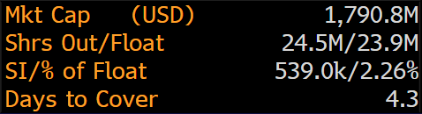
Short Interest measures should play a role in whether this stock is a buy or sell due to its unique business. International Speedway Corporation has a 2.26 percent short interest of float, which is relatively low. I think that short interest for ISC is in a spectrum that would promote a buy.

One Daytona:
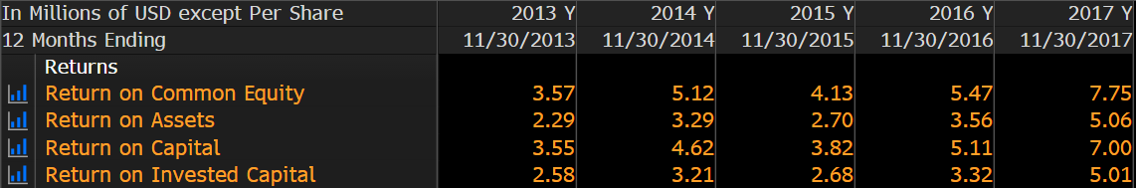
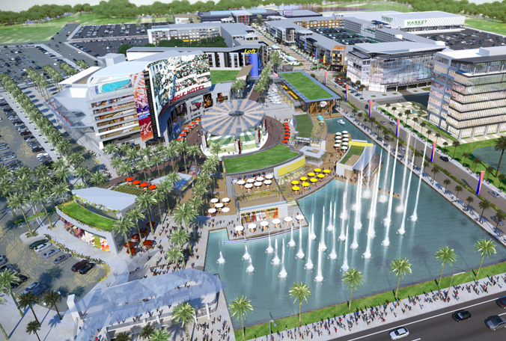
International Speedway Corporation has engaged in a long-term project in conjunction with Marriott Autograph Collection hotel to create a special hotel capturing the essence of Daytona. The project has been labeled One Daytona after the name of the newly built hotel. This project includes the construction of the surrounding areas to provide marketplaces, which ISC can rent out to retailers. One Daytona sits immediately across the street from Daytona International Speedway making it extremely convenient for fans. Leasing activity is currently ongoing and will continue to expand with the building of the new hotel, The Daytona. The hotel is a Marriott Autograph Collection hotel and has an expected opening in late 2018. Construction on the Shoppes at One Daytona, a retail dining venture, is currently in the process of being completed. The entire One Daytona project is scheduled to be completed in 2020. With the completion of One Daytona, ISC is expecting $10 million to be contributed to incremental EBITDA. Estimates of returns on capital are showing dramatic increases on their values that have been showing consistent growth for the past three years. ISC has shown their ability to adapt their facilities to the changing climate of auto racing. The One Daytona project was created to bring more race fans back to the track for a more holistic experience. Other projects at tracks like Richmond and Kansas are underway in an effort to bring more fans back to the tracks. Integration of pit zones and garages (places which fans were not permitted to enter due to injury hazards and driver protection) are being implemented to bring fans closer to the action than ever before. The ability to talk with your favorite driver and see the race teams work on the cars are proving to make fans more eager to come back for more races. The garage areas are going to bring more fans back to NASCAR events, which will bring more revenue in return.

NASCAR:
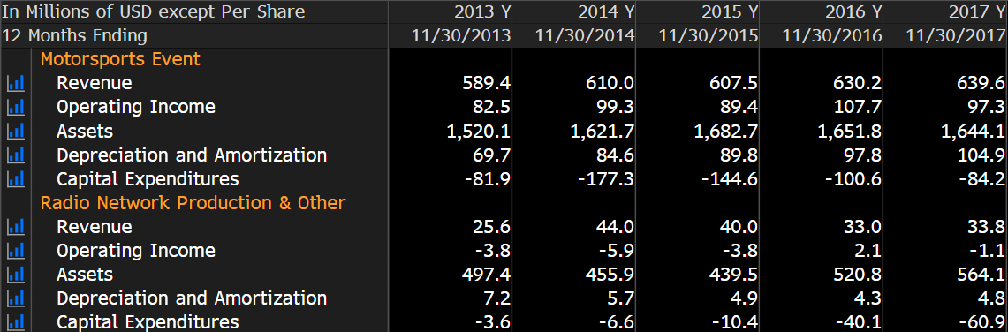NASCAR has the biggest impact on the performance of ISC. The health of NASCAR as a sport has been in recovery in the past years. Auto racing has lost many popular racers due to retirement, injury and even death. It has been argued that since the passing of Dale Earnhardt at Daytona International Speedway in 2001, the popularity of the sport has suffered. Legendary racing names like Dale Earnhardt Jr. and Jeff Gordon announced their retirement in the past two seasons and the upcoming retirement of seven-time champion Jimmie Johnson will leave the sport with a large hole for fans. Executives of NASCAR have been baffled on how to compete with other sports and leagues such as the NFL, MLB, and even golf. The health of ISC is directly correlated with the health of NASCAR. If popularity and viewership rises in NASCAR, ISC will see the spike in their revenues for the event as well as the broadcast portion of their business. Broadcast is a relatively smaller portion of the company’s revenues but still constitutes $34 million of their overall revenue. NASCAR has been active in promoting their brand to encourage more new viewers. The lack of big personalities in the sport has been a struggle for viewers to remain engaged in auto racing. Without somebody to watch or cheer for, fans are directing their attention away from NASCAR. This is being addressed by bringing in new drivers to help boost more comparisons between drivers and fans. Drivers like Erik Jones, a 21-year-old prodigy of popular driver Kyle Busch, looks to bring more young viewers to the sport. NASCAR has seen more viewers come back to the sport since its stagnation in the early 2010s. The future looks brighter with new drivers and new facilities in the sport.

